2-way Thermostatic Control Valve

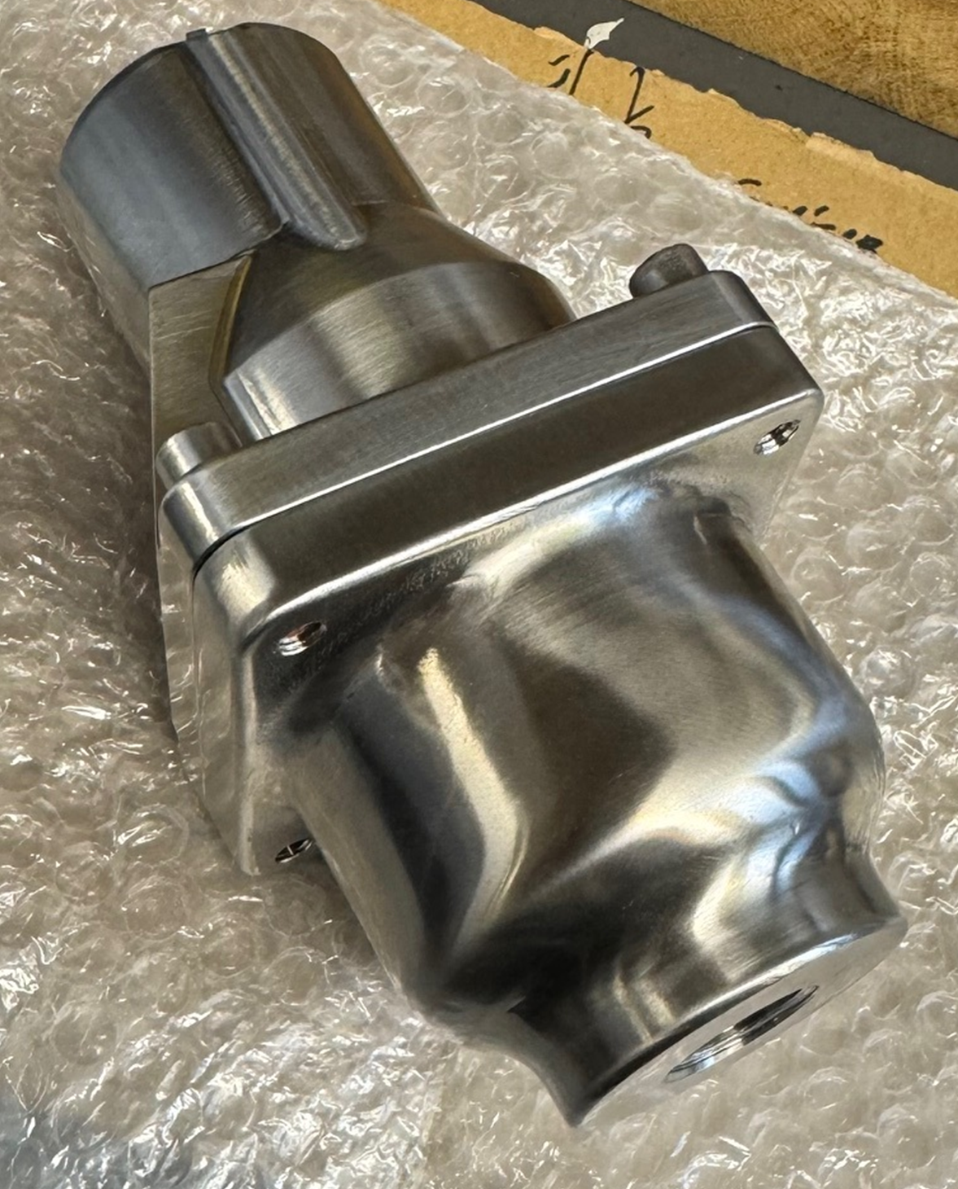
Typical applications
- Temperature control in various systems such as tanks, district‑heating installations, engines, and gear units.
- Temperature limitation – prevents excessively low temperatures, functioning as frost protection.
- Temperature limitation – prevents overheating in hot‑water pipelines (anti‑scald protection).
- Water‑saving systems – maintains a minimum flow through the cooler for proper operation but shuts down unnecessary flow when the temperature is sufficiently low or high.

Key benefits
- No external power source required – simple, low cost installation.
- No user setting needed, “fit and forget” and tamper‑resistant.
- Small number of parts – simple maintenance and low cost of ownership.
- Robust design capable of high vibration and shock applications.
- Any mounting position and explosion‑proof.

Key features
- Flow rates of 0.3–6.5 m³/h.
- Housings in carbon steel, 316 stainless steel and NANO treaded 316 stainless steel for saltwater.
- DN15 – DN25 – DN25
1/2” – 3/4” – 1”
- Threaded connection, BSPP or NPT.
- Tamper‑proof temperature settings from 18°C – 113°C.
- Pressure ratings up to 40 bar.
- Two-way thermostatic valve is supplied in two versions:
- Opens with rising temperature
- Opens with falling temperature

Accreditations available
- SEP
- PED (Group 1 & 2 liquids — ensure material compatibility)
- ATEX II 2G Ex h IIC T6...T3 Gb X
- Complies with relevant EU directives

Overview
Model C thermostatic valves cover multiple sizes and settings for fluid temperature control. They can be mounted in any position and use the expanding wax principle to actuate element assemblies. Typical uses: anti‑scald hot water systems, radiant heating, electronics/battery cooling, pump temperature relief.
Temperature settings: 18°C–113°C. For durability avoid continuous operation within 14°C of the max continuous rating.

Materials
Housing: Carbon steel, 316 stainless steel and NANO treaded 316 stainless steel for saltwater.
Seals: Buna N/Nitrile; Viton; Neoprene.
Elements: Nickel‑plated/Stainless steel

Leak holes
Optional leak holes 1 – 5 mm to allow small sensing flow.

Applications
Water saving: maintains minimum cooler flow; consider internal leakhole for sensing.

Valve characteristics
Recommended sizing Δp: 0.14–0.5 bar.

Flow rate (m³/hr) – Water
The flow values shown in the table below apply to a fully open valve and water as the medium.

Flow coefficient (calculated)
Kv is the metric flow coefficient used to describe the hydraulic capacity of a valve. It expresses how much water can flow through the valve under standardized conditions. Kv is defined as the volumetric flow of water in cubic meters per hour (m³/h) at a temperature of 16 °C, passing through the valve with a pressure drop of 1 bar. In practical terms, a higher Kv value means a valve allows more flow for a given pressure drop, while a lower Kv indicates a more restrictive valve.

Temperature and element characteristics

Element type and seal material

Specification

Weights (approx.)
3 kg for all sizes in carbon steel, 316 stainless steel and NANO treaded 316 stainless steel.
Maintenance & service parts (highlights)
Recommended service interval: ≤ 36 months.
Standard configurations STOCKED
2-WAY DN15, DN20 and DN25, BSPP, 316SS, STD ELEMENT, NITRILE, MANY DIFFERENT SETTEMP.
Stocked SETTEMP

Set temp 18°C
Set temp 24°C
Set temp 29°C
Set temp 35°C
Set temp 38°C
Set temp 43°C
Set temp 49°C
Set temp 54°C
Set temp 60°C

How to define the model code

